A CENSUS OF ITALIAN SEA CAVES
Graziano Ferrari
(No affiliation)
Via Vignati 18, I-20161, Milano, Italy – gwferrari@gwferrari.it

SUMMARY

In 2001 CLEM, an independent research center in marine sciences, performed a census of Italian sea caves. The aim was to gather a general view of scientific knowledge about sea caves in Italy. Thanks to the sponsorship of the Italian Ministry of the Environment, the census was published in 2003. A large multi-authored book collects 50 papers on the various aspects of sea caves scientific relevance. A bibliographic reference of nearly 1000 entries completes the book. An attached CD-rom contains the book papers in html format and the actual census. 1048 caves are registered, but many more are to be discovered.

Introduction
The scientific and environmental importance of sea caves is well known. The European Commission enclosed sea caves in the list of endangered habitats, that are worth a special protection status (LIFE Directive, 92/43/EC, Annex I).
However, scientific and environmental knowledge about sea caves in Italy was dispersed among several sources: caving associations, divers, cave-divers, sea biology researchers, geologists, archaeologists, sea-bound environmentalist associations and so on.
In 1997, Fabio Cicogna proposed a data collection of all scientific aspects of sea caves. Sponsorship and funding from the Italian Ministry of the Environment was granted to the project. The result is a large book with an attached CD-Rom, published in 2003.

Fabio Cicogna and CLEM
Fabio Cicogna (1925-2004) was a philanthropic supporter of marine science research. In 1978 he established CLEM (Centro Lubrense di Esplorazioni Marine – Lubrensic Center on Sea Exploration) in Massalubrense (Naples, Italy). CLEM was a non-profit organization; it sponsored and supported a large number of research works and dissertations, mainly on biology and ecology of marine habitats. From the beginning, the interest in sea caves was relevant. Such interest stemmed mainly from the parallel interest in red coral (Corallium Rubrum).
CLEM produced two scientific books on red coral (with the sponsorship of the Italian Ministry of Agriculture and Fishery), a media campaign against the edible use of the date-shell (Litophaga litophaga) and the feasibility study of the “Punta Campanella” protected marine area (Naples, Italy).

History of the census on sea caves
In 1997, the general interest in sea caves evolved into a more defined project. Fabio Cicogna proposed to Prof. Paolo Forti (University of Bologna) and to the Italian Speleological Society to cooperate in a nation-wide, multidisciplinary collection of information about Italian sea caves. At the time, the author was the coordinator of the Cave Register Board of the Italian Speleological Society. The National Cave Register Board, structured in regional branches, summed up data sheets about nearly 30.000 caves, but sea caves owed no special evidence.
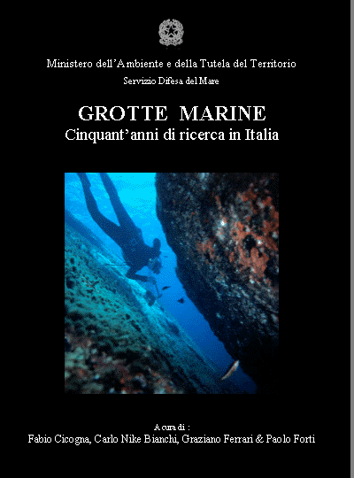 Figure 1 - The book cover
(photo by R. Pronzato, about 1970)
Furthermore, exploration of sea caves is carried out by several groups (cavers, university researchers, divers, etc.), and some of them do not report to caving associations. A data collection was needed, with the cooperation of all the involved groups. Fabio Cicogna and the author cooperated in the definition of a detailed project.
The author left the Cave Register Board, but continued to arouse interest in the project from the Cave Register and several regional and local caving associations. In the meantime, Cicogna aroused interest from geology and biology researchers and from Legambiente, a large environmental organization with a strong involvement in marine protection.
In 1999 the project was submitted to the Italian Ministry of the Environment, Sea Protection Directorate. It was approved and funded at the end of 2000.

Development of the sea caves’ census
The project started effectively on 17th February 2001 and it was planned to last for 18 months. Fabio Cicogna acted as project manager, with help from the author. Prof. Paolo Forti supervised the geological section and Prof. Carlo Nike Bianchi (presently at the University of Genova) coordinated the biology / ecology section. The author was also in charge of the actual data collection. These four people composed a project management board, and they acted as the book editors.
The project result was designed as a multi-authored book collecting a large number of scientific contributions about several aspects of sea cave sciences. A specific section about technical issues was added (tools, techniques, training, rescue). An attached CD-Rom was designed to contain the papers printed in the book and the actual cave census data sheets, as plain web pages. Furthermore, a small collection of representative images and movies was added.
The editing work proceeded for about a year, with few problems.
On the register side, however, the Italian Speleological Society refused to sign an agreement about cave register data. Sea caves’ data collection proceeded anyway. It was based on a comprehensive bibliographical research, performed in large part at the “Franco Anelli” Speleological Documentation Center, at the University of Bologna (thanks to Prof. Paolo Forti and to Michele Sivelli). Further data were collected thanks to researchers, divers, cave divers, diving centers.
Finally, the Italian Speleological Society agreed to share its data, mainly thanks to the present coordinator of the Cave Register Board, Prof. Paolo Mietto (University of Padova). This subsequent agreement, together with Fabio Cicogna’s health problems, accounted for an overall delay of 6 months in the project completion. 1048 single caves were identified. A survey was available for 548 of them (429 directly from the survey authors or from publications, 119 from the Cave Register). Publication of each survey was explicitly permitted by the author, by the original publication ownership or by the Cave Register.
The book is not for sale. 1000 copies were printed; about 500 were sent free of charge to: regional environmental management agencies, marine protected areas, central and local directions of the Harbor Master’s Office (“Capitanerie di Porto”), institutions and researchers involved in sea cave studies, scientific libraries, central and local cave register offices, national heads of the Cave Rescue Corp, members of the Cave Diving Commission of the Cave Rescue Corp, single paper authors and single data contributors.

The book structure
The book is designed as a collective work, with 54 authors contributing a total of 50 single papers. All the contributions are in Italian, with a collective summary in English. It was gathered and edited by C. N. Bianchi and C. Morri. The following notes are abridged from the book summary.
The book starts with a Presentation by Dr. Aldo Cosentino, Director General of the Sea Protection Directorate of the Ministry of the Environment. The Introduction by Fabio Cicogna and the list of authors follow.
The book is structured in seven largely independent parts. The first part shortly retraces the history of exploration and scientific research on sea caves.

Geology
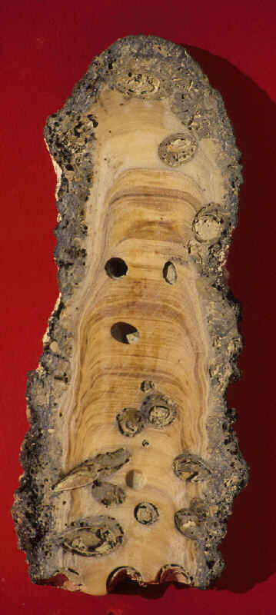
Figure 2
Stalagmite section,
Grotta Scaletta, Palinuro
Sampling depth: -48 m
(photo by F. Antonioli)
The second part, coordinated by Prof. P. Forti, with considerable help from Dr. F. Antonioli, is devoted to the geology, geomorphology and palaeontology of sea caves.
Dealing with cavities of continental origin and their marine evolution, the authors maintain that the short period variations (induced by tides and atmospheric pressure) may be disregarded because they have practically no effects on speleogenesis. But other factors like ice melting due to climatic variations, tectonic movements, elastic movements induced by glaciostasy and isostasy, and also subsiding movement of the coastal plains must be taken into consideration because they may heavily control the evolution of caves along the seashore. Therefore it is important to know the variation of the sea level zone by zone in detail because the effect of isostasy, the tectonic behaviour and many other factors, may change dramatically even within a few kilometers. The evolution of the sea caves is normally proportional to the period the sea water remained in contact with the hosting rock and therefore the largest of such cavities have been normally observed where the average sea level has been relatively constant in time.
On the basis of the definition given at the beginning, sea caves may develop in any kind of lithology, but their genesis may be extremely different. Therefore it is useful to split sea caves into two different categories:
- Marine ingression caves
- Sea caves (sensu strictu)
All the continental caves belong to the first group, their genesis being independent from the presence of the sea: they may be tectonic, eolian, volcanic or karst cavities flooded by the sea when its level rose. The marine ingression caused nothing else than the stop in the speleogenetic evolution of such cavities.
A whole chapter is devoted to the caves of the second group, which are said to be far more interesting from the genetic point of view: in fact, their evolution has been directly controlled by the sea water, in a passive manner (primary caves in a reef barrier), in a mechanical manner (littoral caves made by marine erosion), or in a physico-chemical manner (mixing water caves). The genetic mechanisms for all these caves are shortly discussed.
A further chapter deals with chemical and physical deposits. Cave environment is extremely conservative; moreover nearly all the cavities, and mainly the marine ones, may be partially or totally filled by physical and/or chemical materials. The mechanisms which are responsible for sedimentations inside marine caves are briefly reported together with the description of the most peculiar of such sediments. These physical and chemical sediments have a fundamental importance for studying the paleo-climatic and paleo-environmental evolution, in particular for the recent Quaternary.
Finally, the most significant case studies, from the genetic and/or scientific point of view, are reported: minerogenetic environments, underground estuaries, both in Italy and abroad, ipogenic sea caves, important paleo-climatic and paleonthological findings.

Biology
The third and largest part of the book serves as an introduction to the biology and ecology of marine caves. The section was supervised by Prof. C. N. Bianchi. It begins with a purposely done Italian translation of "The role of sea cave investigation in marine sciences", a classical paper by R. Riedl originally published in 1978 by the old and prestigious Pubblicazioni della Stazione Zoologica di Napoli.
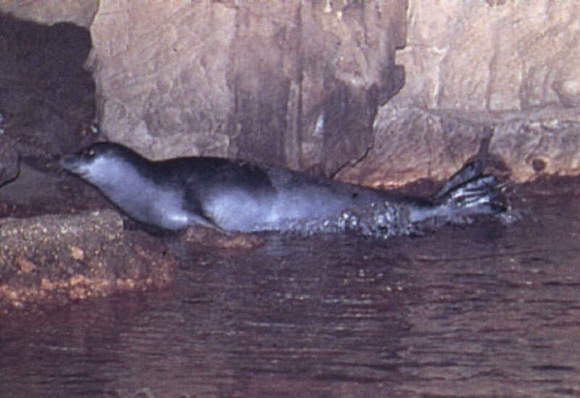
Figure 3 - Monk seal (Monachus monachus)
Grotta del Bue Marino (Sardinia)
(photo by E. Altara, 1967)
The Riedl seminal paper is followed by a large number of chapters organised in six sections, the first of which updates knowledge on the biota of marine caves and opens with a chapter that provides a general outline of the flora and fauna.
Single papers report about present knowledge on sponges, hydroids, scleractinians, molluscs, serpuloidean polychaetes, decapod crustaceans, bryozoans, brachiopods, fish, insects, birds, bats and, finally, the monk seal.

The second section of the biological and ecological part explores evolutionary patterns of marine cave biota, and is composed of three chapters on evolution and speciation, adaptations in marine invertebrates and the anchialine habitats.

The third section consists of four chapters that engage in the main biocoenoses living in submarine caves. They are related to spatial zonation, the infaunal communities, the meiofauna and the plankton.
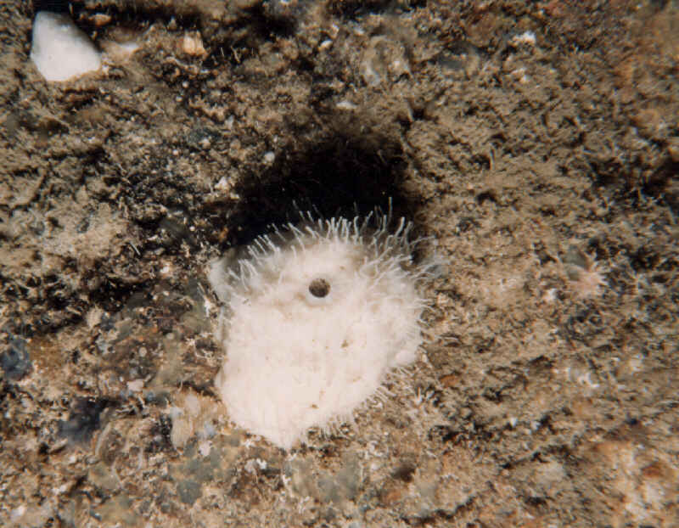
Figure 4 - Petrosia sp. genetically adapted to cave habitat
(photo by G. Bavestrello)

The fourth section takes into account environmental factors. It comprises papers about the relationship between light and marine vegetation, the hydrological confinement and the trophic depletion,

The fifth section approaches ecosystem studies, which take into account community structure and ecosystem functioning. These papers include community structure, trophic organisation, the origin and fluxes of matter and energy in submarine caves and bacterial metabolism.

Last but not least, the sixth section of the biological and ecological part takes care of methodological aspects. The currently adopted sampling and measurement techniques and experimental ecology methods are considered.

Archaeology
The fourth part of the book is devoted to archaeology. A chapter describes techniques and provides examples of researches performed by scuba diving in Italian submarine caves.

Social sciences
The fifth part of the book considers the socio-economic importance of submarine caves and the need of environmental protection. The diving department of the environmentalist association "Legambiente" takes care of these issues, providing a chapter that underlines the positive and negative impacts of recreational scuba diving in sea caves. Possible sources on pollution are stressed, both from inland and sea (oil spill). The several forms of legal area protection are discussed.

Technical issues
Exploring and registering submarine caves is a central topic to all research and management issues about this peculiar environment. It is tackled in the sixth part of the book, comprising four chapters. The first underpins the need for proper underwater techniques and safety rules. Cave diving requires knowledge not included in traditional training. Independently of skills, special equipment is needed and definite rules have to be followed, because safety must be the primary point. Diving materials, dangers and techniques are briefly analyzed. In consequence of the growing diving tourism and in order to avoid accidents and environment damages, it’s up to Port Authorities, Diving Centers and Scientific Communities to establish precautionary measures.
What to do to prevent accidents in sea caves and how to operate for rescue is the concern of the second chapter. An accident in a confined underwater environment, as sea caves are, is usually very serious and results often in fatalities. Prevention relies on a high level psyco-physical training and on suitable specific tools. In case of an accident in a sea cave, several organizations can operate in the rescue. The Corpo Nazionale Soccorso Alpino e Speleologico (CNSAS - National Mountain and Cave Rescue Corp), through its Cave diving Commission, is able to provide a medicalized rescue.
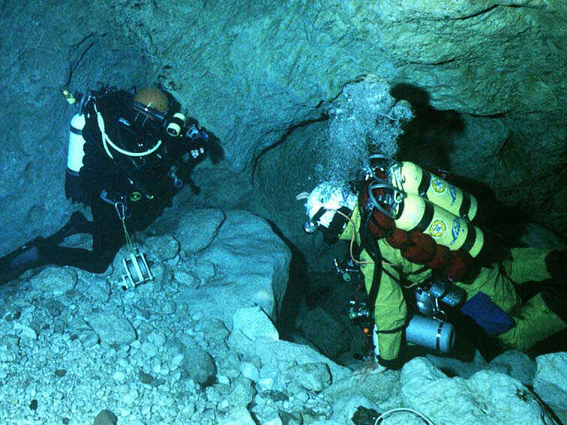
Figure 5 - Cave Rescue Corp training
(photo by G. Spaziani)
The third chapter reports about the present status and future projects of the Italian cave register, managed by the Italian Speleological Society (SSI).
The fourth chapter describes technical aspects and the training structure of the Cave Diving School (SNSS) of the Italian Speleological Society (SSI).

The seventh and last part of the book presents the sea cave census. In five comprehensive chapters, G. Ferrari in turn introduces entry data forms, describes maps, analyses data quality, assesses criteria for quoting sources and data property, and provides an example of form.

In conclusion, Fabio Cicogna reports about the problems concerning a complete and correct multidisciplinary study of a marine cave: professional diving instruction, a homogeneous data collection to permit a comparison among different marine caves and that means the necessity of a particular research protocol.
Figure 6 - The CD-Rom front
(photo by H. Jantschke)
The book ends with an impressive list of nearly one thousand bibliographic references on all aspects of marine cave science.

The CD-Rom
The attached CD-Rom contains five sections:
- Brief presentation of the sponsoring institution (the Italian Ministry of the Environment), of the project coordination associations (CLEM) and of the two main cooperating associations (Legambiente and the Italian Speleological Society).
- The papers printed in the book, converted in plain html format. The reader can easily surf them in sequence or hierarchically.
- The cave census (more on this later).
- The bibliographic references, ordered alphabetically.
- A selection of photos and videos.
The CD-Rom is designed to provide an easy distribution of information. It is independent of the book, so it can reach a wider audience than the limited edition of the book.
All authorship rights about papers, photos, video and surveys are properly acknowledged. In this way, future researchers can properly reference other people’s contribution to sea caving science.

The census
According to the census rules, a sea cave is a cave containing a water body directly or indirectly connected with the sea. The indirect connection accounts for the so called anchialine caves, which contain salt water bodies with no apparent connection with the sea.
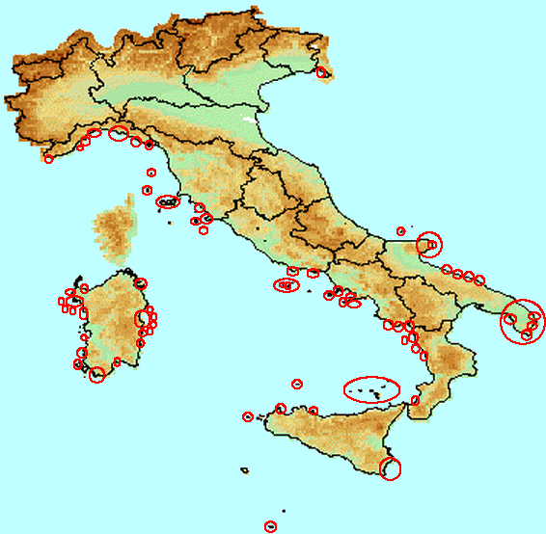
Figure 7 - Map of sea cave areas
Marine related caves which are presently at a higher elevation than the sea level are not comprised in the present version of the census. Both coastal (semi-submerged) and (fully) submerged caves are present.
Of course, data collection is far from complete. Most coastal caves are well known. In some areas, a detailed positioning and surveying work is yet missing or incomplete. On the other hand, few areas can claim that submerged caves have been thoroughly explored and reported. In some areas, the only information is a number of citations from local divers.
As far as size is concerned, the official UIS rules were applied, where possible:
- Development longer or equal than 5 meters.
- Entrance width and height lesser than development.

Of course, most sea caves open in limestone cliffs. However, some caves in sandstone, schist, andesite and tuff are registered. A submerged lava tube is reported in Sardinia.

Each cave is represented by a fact sheet with four main sections:
- Geographic, metric and position data.
- A brief description, usually taken from a publication.
- Surveys and photos, with references to authors and publications.
- Bibliography.
Each fact sheet is designed as a web page, to be displayed on PC with a web browser (Netscape Navigator, Microsoft Explorer, etc.). The overall register has a geographic structure, divided in Regions and in main sea caving areas. The geographic structure allows an easy display of related caves and most searches and selections.
Other available searches are: by Municipality, by name (or part of), by development, by entrance elevation (or depth), by longitude, by latitude.

The collected data were also integrated within the SIDiMar, the geographic information system of the Ministry of the Environment Sea Protection Directorate.

The following table summarizes facts about Italian sea caves, divided by Regions. Separate entries are provided for caves already included in the National Cave Register and for caves not yet included in the Cave Register (due to failure to transfer data to the Cave Register, or to missing / incomplete positioning or missing survey). Each specific data column is further divided into caves with and without survey.

 | Caves | Already registered |  |  | Not yet registered
Region | Caves |  | Surveyed | Unsurveyed |  | Surveyed | Unsurveyed
Basilicata | 17 | 17 | 9 | 8 | 0 | 0 | 0
Calabria | 25 | 18 | 15 | 3 | 7 | 0 | 7
Campania | 238 | 113 | 85 | 28 | 125 | 43 | 82
Friuli-Venezia Giulia | 4 | 4 | 4 | 0 | 0 | 0 | 0
Lazio | 103 | 38 | 12 | 26 | 65 | 0 | 65
Liguria | 53 | 30 | 18 | 12 | 23 | 7 | 16
Puglia | 201 | 185 | 132 | 53 | 16 | 9 | 7
Sardegna | 247 | 156 | 155 | 1 | 91 | 7 | 84
Sicilia | 108 | 23 | 12 | 11 | 85 | 12 | 73
Toscana | 52 | 27 | 21 | 6 | 25 | 7 | 18
Italy | 1048 | 611 | 463 | 148 | 437 | 85 | 352

Future developments
Since the present census is far from complete, the main objective is to further push data collection, with more publications in the geological and biological areas. The diving magazines often report references to unpublished submerged caves. This means more field information from professional divers is needed.
The increasing interest in sea caves caused the definition of a law proposal at the national Parliament. The proposal aims at the protection and the exploitation of sea caves. Care must be taken not to exploit sea caves before the proper scientific studies are performed. The risk is to over-use or abuse little known resources.
A better approach would be the definition of a nation-wide plan of local area research campaigns, aimed to collect a complete and detailed knowledge of sea caves, area by area.
In this sense, a powerful help would come from the use of the multi-beam side-scan sonar. This was the last Fabio Cicogna’s idea about sea caves. Entrances as small as 0.5 meters wide can be identified at depths down to 50 meters. The following pictures show the results of a test performed in Salento (Lecce, Puglia).

Bibliographic references
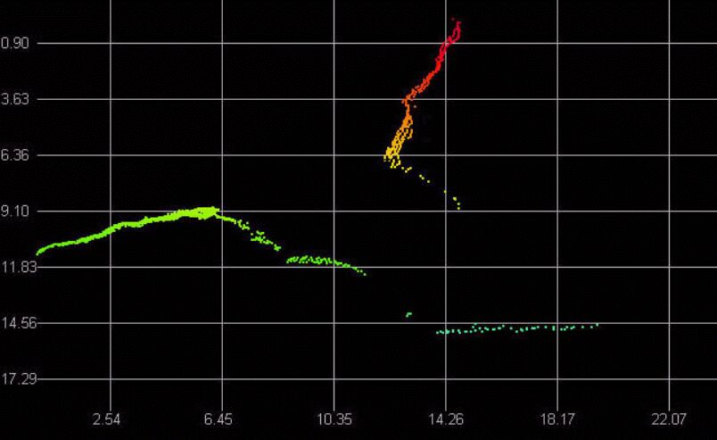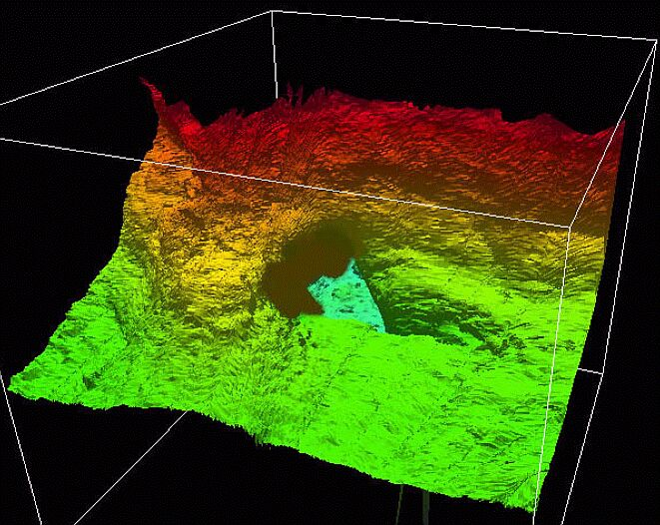
Figure 8 – Sonar profile and 3D digital terrain model of the Grotta delle Corvine entrance (Lecce, Puglia)
Cicogna F., G. Bavestrello & R. Cattaneo-Vietti (eds.), 1999. Red Coral and other Octocorals. Biology and Protection. Ministero per le Politiche Agricole, Roma. 1-338.
Cicogna F., C. N. Bianchi, G. Ferrari & P. Forti (eds.), 2003. Le grotte marine: cinquant'anni di ricerca in Italia. Ministero dell’Ambiente e della Tutela del Territorio, Roma. 1-505.
Cicogna F. & R. Cattaneo-Vietti (eds.), 1993. Red coral in the Mediterranean Sea: Arts, History and Science. Ministero delle Risorse Agricole, Alimentari e Forestali, Roma. 1-263.

